Country: **Ivory Coast**

Year: **2011-2012**

Number of Observations: **9686**

Number of Clusters: **5**

Number of variables used: **27**

Distance used: **Hamming**

**Variables used in the algorithm:** hv206,hv207,hv208,hv209,hv210,hv211,hv227,hv237,hv243a,hv243b,hv244,hv246,hv247,hv252,sh106a,sh106b,sh106c,sh110h,sh110k,sh110l,water,toilet,floor,roof,cookfuel,wall

**Summary of Top Cluster Configurations (ranked by ASW)**

| **Cluster #** | **ASW** | **Variable 1** | **Variable 2** | **Variable 3** | **Variable 4** |
| --- | --- | --- | --- | --- | --- |
| **1** | 0.894005095442965 | hv208 | hv243a | sh110h | sh110l |
| **2** | 0.893709190772348 | hv208 | sh110h | sh110l | floor |
| **3** | 0.892485446611042 | hv208 | hv209 | hv243a | sh110l |
| **4** | 0.892233291306659 | hv208 | hv209 | sh110l | floor |
| **5** | 0.887288117463565 | hv208 | sh110j | sh110l | floor |
| **6** | 0.887140968840387 | hv208 | hv243a | sh110j | sh110l |
| **7** | 0.876736230687124 | hv206 | hv208 | sh110h | floor |
| **8** | 0.876033695854653 | hv208 | hv243a | sh110h | sh110j |
| **9** | 0.874062260111477 | hv208 | sh110h | sh110j | floor |
| **10** | 0.873044474280757 | hv206 | hv209 | sh110h | floor |

**Distributions of ASW values in all clusters in Ivory Coast**

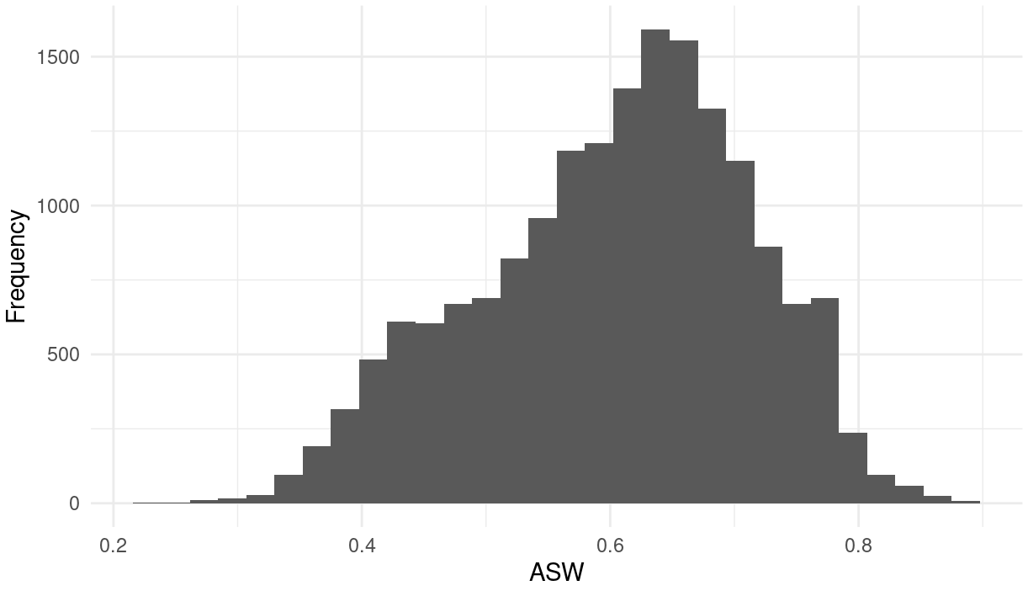

**Marginal Distributions**

| Variable | Description | % time in top clusters | Distribution |
| --- | --- | --- | --- |
| hv206 | Has electricity | 10% | Binary,53.5% 1s (or yes) |
| hv208 | Has TV | 100% | Binary,40.1% 1s (or yes) |
| hv209 | Has refrigerator | 30% | Binary,10.5% 1s (or yes) |
| hv243a | Has mobile telephone | 40% | Binary,79.3% 1s (or yes) |
| sh110j | Owns stove or burner | 60% | Binary,10.4% 1s (or yes) |
| sh110l | Owns cd/dvd player | 40% | Binary,24.1% 1s (or yes) |
| sh110h | Owns cable subscription | 60% | Binary,11.4% 1s (or yes) |
| floor | Type of floor in dwelling | 60% | Categorical,  0 = 22.50%  1 = 0.07%  2 = 77.23%  3 = 0.20% |

**Summary of variable distributions in top clusters**

Currently our method is choosing five distinct clusters of individuals within each cluster variable configuration. Here are the medioids for each of these five clusters:

**Cluster #1 Configuration**

| **Config #** | **Node** | **hv208** | **hv243a** | **sh110h** | **sh110l** | **Proportion** |
| --- | --- | --- | --- | --- | --- | --- |
| **1** | 1 | 1 | 0 | 0 | 1 | 14.93% |
| **2** | 1 | 1 | 1 | 0 | 1 |
| **3** | 2 | 0 | 1 | 1 | 1 | 8.63% |
| **4** | 2 | 1 | 0 | 1 | 1 |
| **5** | 2 | 1 | 1 | *1* | 1 |
| **6** | 3 | 0 | *0* | 0 | 0 | 19.16% |
| **7** | 3 | 0 | 0 | 0 | 1 |
| **8** | 4 | 1 | 0 | 0 | 0 | 16.56% |
| **9** | 4 | 1 | 0 | 1 | *0* |
| **10** | 4 | 1 | 1 | *0* | 0 |
| **11** | 4 | 1 | 1 | 1 | 0 |
| **12** | 5 | 0 | 1 | 0 | 0 | 40.72% |
| **13** | 5 | 0 | 1 | *0* | *1* |
| **14** | 5 | 0 | *1* | 1 | 0 |

**Validation of Top Cluster with Chi-Sq Distribution**

Note that in the tables, the rows are the validation variables, and the columns are the node number from the cluster distributions in the table above.

